***Software Engineering Requirement***

***Lecture # 6***

***Requirements Engineering Process***

The process(es) involved in developing system requirements is collectively known as Requirements Engineering Process

***RE Process - Inputs and Outputs***

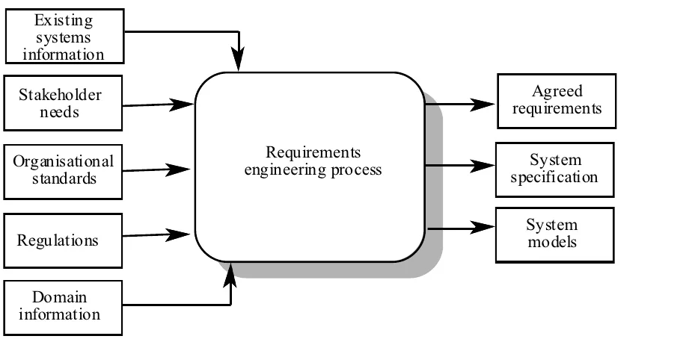

***RE Process – Inputs***

* **It includes:**

***Existing system information***

* Information about the functionality of systems to be replaced
* Information about other systems, which interact with the system being specified

***Stakeholder needs***

* Description of what system stakeholders need from the system to support their work

***Organizational standards***

* Standards used in an organization regarding system development practice, quality management, etc.

***Regulations***

* External regulations such as health and safety regulations, which apply to the system

***Domain information***

* General information about the application domain of the system

***RE Process – Outputs***

* **It includes**

***Agreed requirements***

* A description of the system requirements, which is understandable by stakeholders and which has been agreed by them

***System specification***

* This is a more detailed specification of the system, which may be produced in some cases

***System models***

* A set of models such as a data-flow model, an object model, a process model, etc., which describes the system from different perspectives

***RE Process Variability***

* RE processes vary radically from one organization to another, and even within an organization in different projects
* Unstructured process relies heavily on the experience of the people, while systematic processes are based on application of some analysis methodology, but they still require human judgment

**There are four factors which count towards the variability of the Requirements Engineering Process**

* Technical maturity
* Disciplinary involvement
* Organizational culture
* Application domain

***Technical maturity***

* The technologies and methods used for requirements engineering vary from one organization to other

***Disciplinary involvement***

* The types of engineering and management involved in requirements vary from one organization to another

***Organizational culture***

* The culture of an organization has important effect on all business and technical processes

***Application domain***

* Different types of application system need different types of requirements engineering process

***Requirement Engineering Process***

**Requirement Engineering Process has a formal starting and ending point in the overall software development life cycle.**

***Begins***

* There is recognition that a problem exists and requires a solution
* A new software idea arises

***Ends***

* With a *complete* description of the external behavior of the software to be built
* It is a continuous process in which the related activities are repeated until requirements are of acceptable quality
* It is one of the most critical processes of system development
* Based on the need of individual software projects and organizational needs, requirements engineering processes are tailored
* An important point to remember is that

**“There is no ideal requirements engineering process!”**

***Two Main Tasks of RE***

There are two main tasks which needs to be performed in the requirements engineering process.

***Problem analysis***

* Analysis of a software problem

***Product description***

* Complete specification of the desired external behavior of the software system to be built. Also known as functional description, functional requirements, or specifications

***Problem Analysis***

Problem analysis is the first and foremost task of requirements engineering process. It includes:

* Brainstorming, interviewing, eliciting requirements
* Identifying all possible constraints
* Expansion of information
* Trading off constraints and organizing information
* Complete understanding should be achieved

***Product Description***

Product description is another task of requirements engineering process. In this task we:

* Make decisions to define the external behavior of the software product
* Organize ideas, resolve conflicting views, and eliminate inconsistencies and ambiguities

**What Really Happens**

It should be kept in mind that:

**“Both problem analysis and product description run in parallel and iteratively throughout the requirements engineering process”**

***Requirements Engineering Activities***

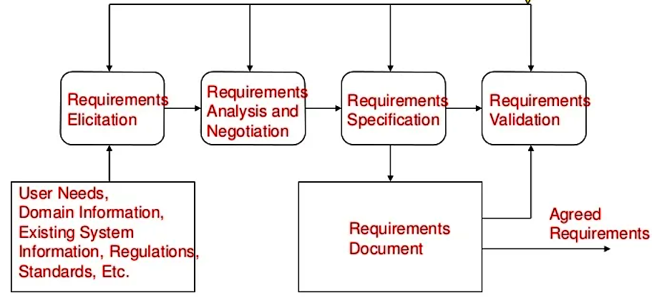

***Requirements Elicitation***

Requirements elicitation activity is performed by

* Determining the system requirements through consultation with stakeholders, from system documents, domain knowledge, and market studies
* Requirements acquisition or requirements discovery

***Requirements Analysis and Negotiation***

Requirements analysis and negotiation activity is performed by

* Understanding the relationships among various customer requirements and shaping those relationships to achieve a successful result
* Negotiations among different stakeholders and requirements engineers
* Incomplete and inconsistent information needs to be tackled here
* Some analysis and negotiation need to be done on account of budgetary constraints

***Requirements Specification***

Requirements specification includes

* Building a tangible model of requirements using natural language and diagrams
* Building a representation of requirements that can be assessed for correctness, completeness, and consistency

***Requirements Document***

* Detailed descriptions of the required software system in form of requirements is captured in the requirements document
* Software designers, developers and testers are the primary users of the document

***Requirements Validation***

* It involves reviewing the requirements model for consistency and completeness
* This process is intended to detect problems in the requirements document, before they are used as a basis for the system development

***Requirements Management***

* Although, it is not shown as a separate activity in RE Process, it is performed throughout the requirements engineering activities.
* Requirements management asks to identify, control and track requirements and the changes that will be made to them

***Summary***

* Requirements engineering is the process by which we can systematically determine the requirements for a software product
* It is one of the most critical processes of software life cycle
* If performed correctly, it sets the software project on a track which results in a successful project